S4584569 Alev Akturk Tutorial 10

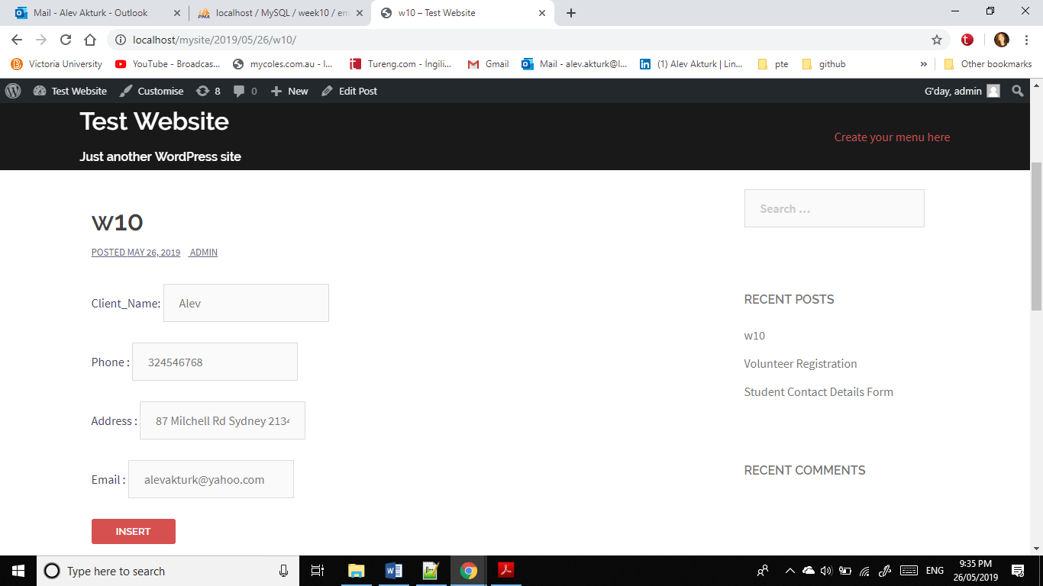

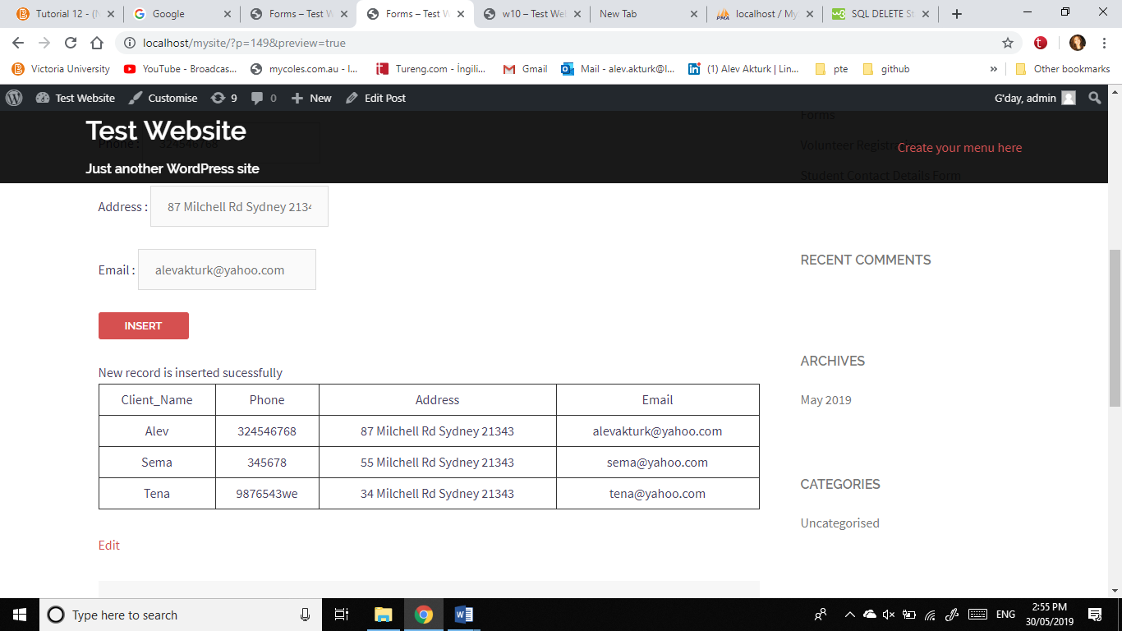

**CODES**

/* How to insert form through SQL*/

$mdebug=1;

$site_url=get_site_url();

$actionPage="$site_url/insert-data-form"; //form name and call itself

echo " <form style='margin: 0; padding: 0;' method='post' action='' >";

echo "Client_Name: <input type='text' name='Client_Name' value='Alev' /><br><br>";

echo "Phone : <input type='text' name='Phone' value='324546768' /><br><br> ";

echo "Address : <input type='text' name='Address' value='87 Milchell Rd Sydney 21343' /><br><br> ";

echo "Email : <input type='text' name='Email' value='alevakturk@yahoo.com' /><br><br>";

$random_n=rand(0,100000); //submitted form has a different random number

echo "<input type='hidden' name='random_n' value='$random_n' /> ";

echo "<button style='padding:0; vertical-align:middle; height:33px; width:110px;' type=submit> Insert </button> ";

echo "</form>";

echo "<br>";

insert_function($random_n, $mdebug); // This function will submitted the form.

function insert_function($random_n, $mdebug)

{

/*database connection */

$server="localhost"; $username="root"; $password=""; $db="week10";

$companydb = new wpdb($username,$password,$db,$server);

if ($companydb==null)

echo "DB Connection failed. Check your database connection account.<br>";

else

{

/* check if the form is submitted, construct insert string, then insert */

$form_random_n=$_POST["random_n"];

if ($form_random_n!=null && $form_random_n!=$random_n)

{

$Client_Name=$_POST["Client_Name"];

$Phone=$_POST["Phone"];

$Address=$_POST["Address"];

$Email=$_POST["Email"];

$qstr="insert into employee (Client_Name,Phone,Address,Email) values ('$Client_Name','$Phone','$Address','$Email')";

$companydb->query($qstr);

echo "New record is inserted sucessfully";

}

else{

echo "Error: ". $sql ."

". $conn->error;

}

}

select_display($companydb,$mdebug);

}

function select_display($companydb,$mdebug)

{

$qstr="select * from employee order by Client_Name";

$rows = $companydb->get_results($qstr);

if($rows==null) echo "No record found in query: $qstr <br>";

else{

$field_num=4;

$field_names=array("Client_Name","Phone","Address","Email");

$display_names=array("Client_Name","Phone","Address","Email");

echo "<table border=1><tr>";

for($i=0;$i<$field_num;$i++)

echo "<td>$display_names[$i] </td>";

echo "</tr>";

foreach ($rows as $row)

{

echo "<tr>";

for($i=0;$i<$field_num;$i++)

{

$field_name=$field_names[$i];

$field_data=$row->$field_name;

echo "<td>$field_data </td>";

}

echo "</tr>";

}

}

echo "</table>";

}